SESSION 9 ASSIGNMENT 2

**Problem 1:**

**Create an HBase table named 'clicks' with a column family 'hits' such that it should be able to**

**store last 5 values of qualifiers inside 'hits' column family.**

Soln.

hbase-start.sh

hbase shell

create ‘clicks’, {NAME=>’hits’, VERSIONS=>’5’}

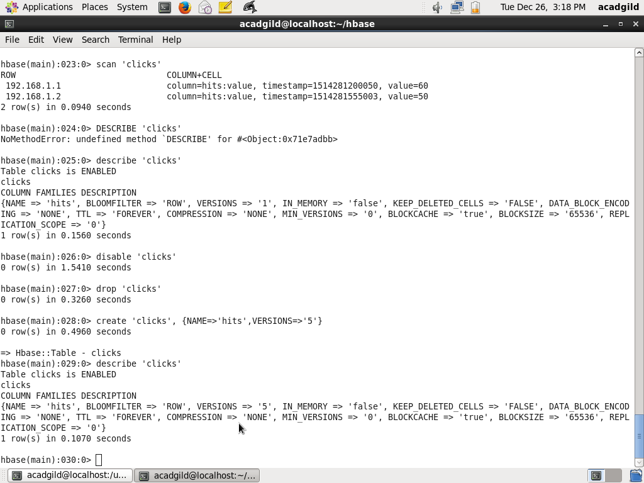

**Problem 2:**

**Add few records in the table and update some of them. Use IP Address as row-key. Scan the**

**table to view if all the previous versions are getting displayed.**

Soln.

Put ‘clicks’, ‘192.168.1.1’, ‘hits:value’, ’10’

Put ‘clicks’, ‘192.168.1.1’, ‘hits:value’, ’20’

Put ‘clicks’, ‘192.168.1.1’, ‘hits:value’, ’30’

Put ‘clicks’, ‘192.168.1.1’, ‘hits:value’, ’40’

Put ‘clicks’, ‘192.168.1.1’, ‘hits:value’, ’50’

Put ‘clicks’, ‘192.168.1.1’, ‘hits:value’, ’60’

Put ‘clicks’, ‘192.168.1.0’, ‘hits:value’, ’50’

Put ‘clicks’, ‘192.168.1.0’, ‘hits:value’, ’70’

Put ‘clicks’, ‘192.168.1.0’, ‘hits:value’, ’78’

Scan ‘clicks’, {COLUMN=>’hits:value’, VERSIONS=>6}

